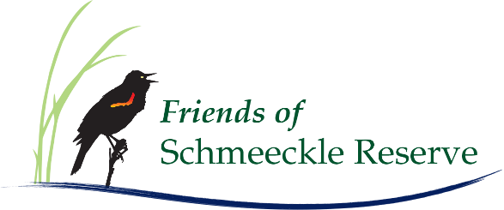
Art, Writing & Photography Contest

Submissions are invited for the annual Friends of Schmeeckle Reserve Art, Writing & Photography Contest. Entries should be inspired by and based on Schmeeckle Reserve. All work must be original and must be created by the submitter. Judges shall determine appropriateness of all entries and categories.

Deadline: Submissions must be received by Dec. 4, 2026, at 4 p.m. You may submit in all four categories but may submit only one entry per category. Include the information requested on the next page for each entry.

Entry Categories and Submission:
Art – Can be any medium of your choice (paintings, sculptures, etc.). Submit entry and submission information at the visitor center at 2419 North Point Drive, Stevens Point.
Writing – Can be an essay, poem, story, etc. Submit entry and submission information via email (info@friendsofschmeeckle.org) as a word document, PDF, or plain text format.
Photography – Images should be high resolution and suitable for print and digital display. Submit entry and submission information via email (info@friendsofschmeeckle.org) as a JPEG, TIFF, PNG, or GIF file.
Note: Some phones alter photo properties when sharing. If using a phone camera, check image quality after downloading or sharing.

Digital Art Category *NEW* – Can include collages, highly manipulated digital photography, digital illustrations, digital sculpting, animations, and more!​ Submit entry and submission information via email (info@friendsofschmeeckle.org).

Entry documents along with the submission information requested below are required. You will receive a confirmation email that your submission has been received.

Reception and Exhibit: Winners will be notified early 2026. The Friends will host a reception on Friday, January 23, 2026, at 4:30 p.m. to recognize and celebrate all entries. All entries will be displayed on the Friends of Schmeeckle website and at Portage County Public Library.

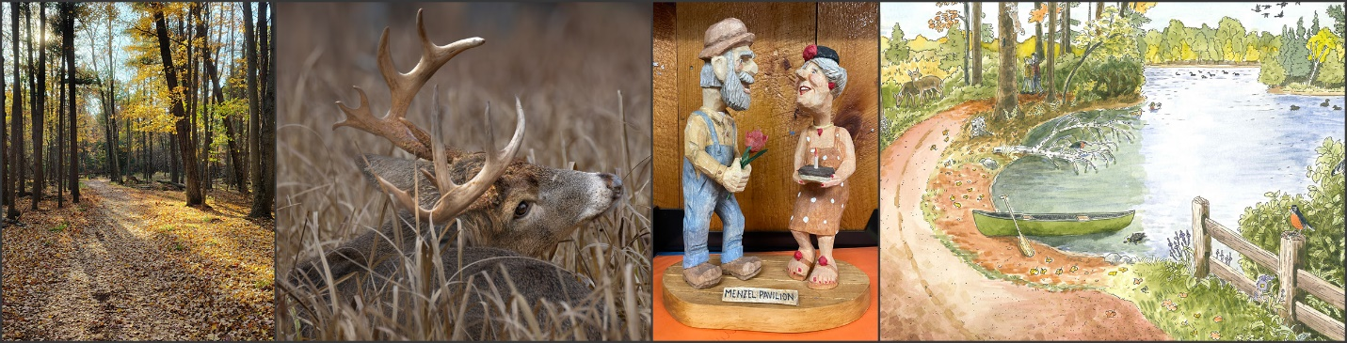

Type of entry (highlight one):
☐ Art: Grade 6 and younger ☐ Art: Grades 7-12 ☐Art: Adult

☐Writing: Grade 12 and younger | ☐Writing: Adult
☐Photography: Landscape – Beginner | ☐Photography: Landscape - Intermediate/Advanced
☐Photography: Wildlife – Beginner | ☐Photography: Wildlife - Intermediate/Advanced
☐Photography: Plants and Fungi – Beginner | ☐Photography: Plants and Fungi – Intermediate/Advanced
☐Photography: Other – Beginner | ☐Photography: Other - Intermediate/Advanced
☐Digital Art – Beginner | ☐Digital Art – Intermediate/Advanced
Your name: Click or tap here to enter text.

Email address: Click or tap here to enter text.

Telephone number: Click or tap here to enter text.

Address: Click or tap here to enter text.

If submitting as part of a class, list name of school, class, and teacher: Click or tap here to enter text.

In 75-100 words, explain how Schmeeckle Reserve inspired and led to your creative submission. This information is required for entry to be considered. Include specific locations in the Reserve where relevant. Mark the following box if you do not wish for your inspiration statement to be shared. ☐

Click or tap here to enter text.

Rights: Entrants retain all rights to their own work. The Friends of Schmeeckle Reserve may display your submission on its webpage, in marketing materials, or in the Schmeeckle Reserve Visitor Center. Friends of Schmeeckle Reserve and Schmeeckle Reserve are not responsible for lost, stolen, or damaged items.

